DR.SIDHARTH SHRIKANT JOSHI

Ambitious qualified Periodontist and implantologist, Laser dentist with excellent organizational and interpersonal skills, keen to secure a position with dynamic and progressive periodontal and implant practice. Dedicated and dynamic Periodontist with extensive experience providing expert periodontal and implant treatment. Exceptional patient’s skills focused on periodontal treatment and care as well as preventive management. An Ideal candidate for position requiring drive, initiative, responsibility, and challenge

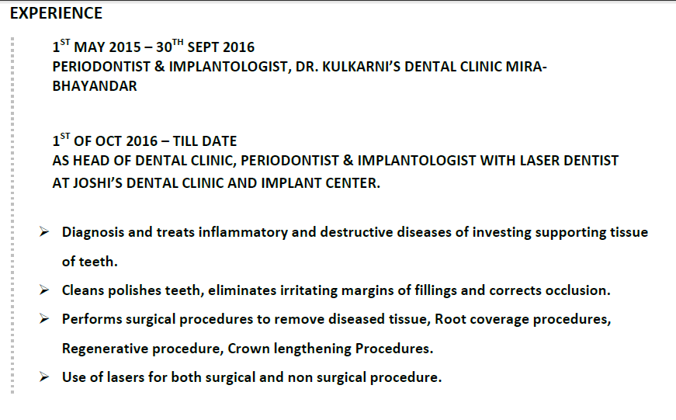
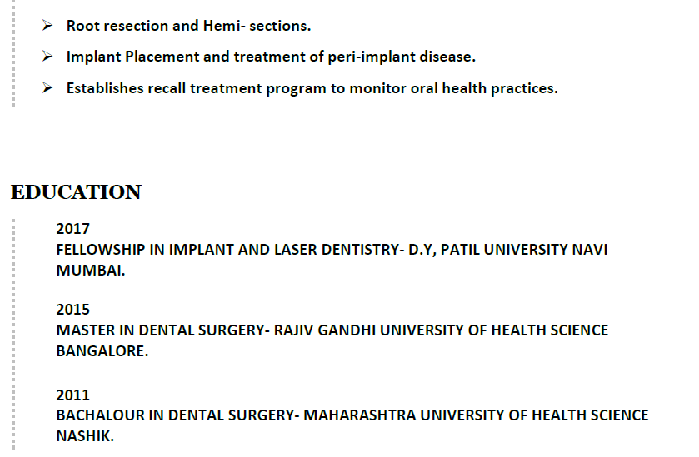
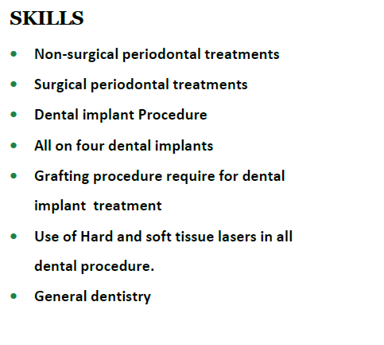
PUBLICATIONS
