RESUME
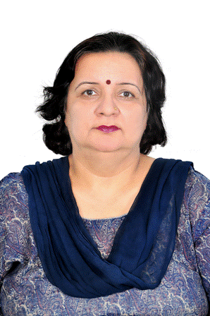

NAME: DR. MINOO NAVKIRAN
DATE OF BIRTH : 9TH AUGUST, 1962
QUALIFICATION: M.B.B.S., M.D. (PATHOLOGY)
FATHER’S NAME : PROF. SOHINDERJIT SINGH
HUSBAND’S NAME: MR. VARINDER SINGH DHALIWAL
PASSPORT NO.: J 3523221

DESGINATION (Last held) : PATHOLOGIST, POLY CLINIC
JEDDAH, KSA.
REGISTRATION NO (India). : PUNJAB MEDICAL COUNCIL (INDIA)-24317
REGISTRATION NO (KSA) : SAUDI COUNCIL OF HEALTH SPECIALITIES-
NO. 07-J-M-0027319
Qualified – Basic Life Support Provider Examination conducted by Saudi
Council of Health Specialties, affiliated to American Heart Association Basic
Life Support Program.

YEAR OF JOINING MBBS AUG 1980

YEAR OF PASSING MD JULY 1990

EXPERIENCE DETAILS (POST MD)
SABHARWAL DIAGNOSTIC LABORATORY, Ludhiana, INDIA. Jr. Pathologist 1st Aug 1990 to 20th July 1991.
DR B.L. KAPUR MEMORIAL HOSPITAL LUDHIANA, INDIA. Pathologist I/C & BTO
1st Aug 1991 to 30th April 2000 Managing a fully automated lab for Haematology,Biochemistry,Citology,Endocrinology and Histopathology.
OWNER : Dr Minoo’s Diagnostic Labs,118 New Lajpat Nagar Pakhowal Rd. Ludhiana.Pb. India –April 2000 to Oct. 2007.
Managing a fully automated lab for Haematology,Biochemistry,Citology,Endocrinology and Histopathology.
VIJAYANAND DIAGNOSTIC CENTRE LUDHIANA, INDIA,
CONSULTANT PATHOLOGIST 1ST May 2000 to 23rd Feb 2005
SPS APOLLO HOSPITALS LUDHIANA, Sr. CONSULTANT 11TH April 2005 to 1st Feb 2006
PAHWA HOSPITAL LUDHIANA INDIA, PATOLOGIST
4th April 2006 to 22ndSept 2007
ASSIGNMENT IN SAUDI ARABIA: 21st Nov 2007 till 31ST Dec. 2015
POLYCLINIC JEDDAH DIAGNOSTIC CENTRE
JEDDAH, SAUDI ARABIA
NATURE OF DUTIES
MANAGING A FULLY AUTOMATED LAB FOR CLINICAL
PATHOLOGY, SEROLOGY, BIOCHEMISTRY, ENDOCRINOLOGY& MICROBIOLOGY,
RESPONSIBLE FOR ENROLMENT & RUNNING OF INTERNAL & EXTERNAL QUALITY CONTROL PROGRAMMES.
MANAGING THE DIAGNOSTIC CENTRE (MEDICAL EXAMINATION FOR ISSUE OF
RESIDENTIAL PERMITS).
PRESENT ASSIGNMENT (10th March 2016 till 30th June 2017) : PATHOLOGIST, PUBLIC LABORATORY ,SUNDER NAGAR,BASTI JODHEWAL,LUDHIANA 141007,PUNJAB ,INDIA

DR. MINOO NAVKIRAN

